ROBUST CONTROLS

AUTOMATIC STEERING AND SPEED CONTROL

INTRODUCTION

For automatic speed and steering control of a vehicle an approximated Bicycle model is considered as shown in figure 1. The state space equation is as shown below.

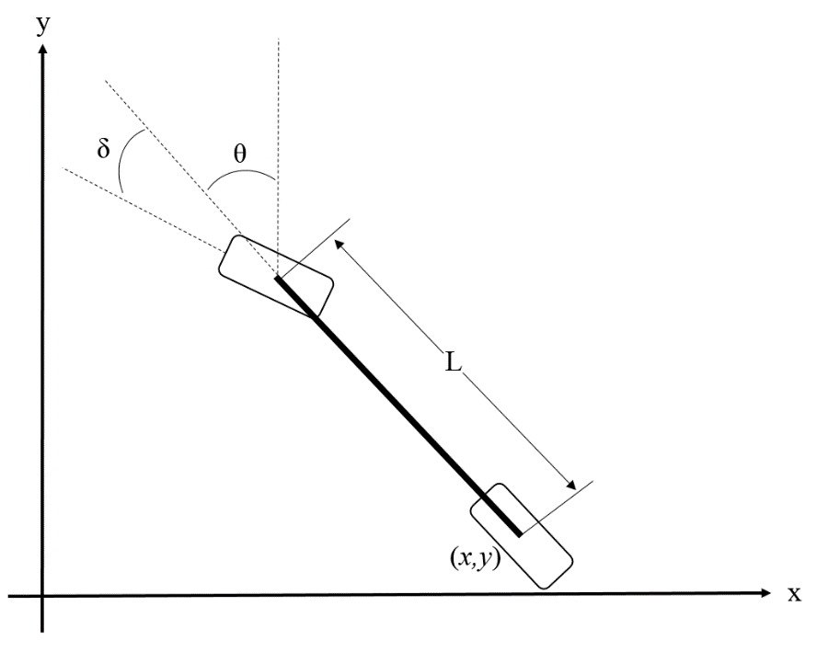

Figure 1. Bicycle Approximation Model

$\dot{\overline{x}}$ = $\left[\begin{matrix}\dot{x} \\ \dot{θ} \\ \dot{y} \\ \ddot{y}\end{matrix}\right]$ = $\left[\begin{matrix}0 & Vref & 0 & 0 \\ 0 & 0 & 0 & 0 \\ 0 & 0 & 0 & 1 \\ 0 & 0 & 0 & A\end{matrix}\right]\left[\begin{matrix}x \\ θ \\ y \\ \dot{y}\end{matrix}\right]$ + $\left[\begin{matrix}0 & Vref/L & 0 & 0 \\ 0 & 0 & 0 & E\end{matrix}\right]\left[\begin{matrix}δ \\ T\end{matrix}\right]$

This equation was used to get the values of A and B. Since each state can be directly measured, C is considered to be the identity matrix and the value of D is set to zero. The performance objectives are to have a stable system, with the maximum allowable *x* error to be 0.44m and the maximum allowable $\dot{y}$ error to be 5 MPH or 2.2 m/s. For the purpose of controller design and analysis, only three states, *x, θ*, and $\dot{y},$ are considered due to *y* being unstable and it can be calculated by integrating $\dot{y}.$

Since the velocity equations and steering equations are completely independent, the state space system can be split into two separate equations without loss of generality. This creates one MIMO system and one SISO system which will simplify the controller design and overall analysis of the systems.

CONTROLLER DESIGN AND ANALYSIS

For configurability and simplicity, a PID controller design was considered and designed using MATLAB and Simulink, with the Simulink model attached. The Simulink model was the same for both the velocity and steering equations. Due to the physical limitations and small angle approximations of the system, a saturation dynamic block was used to constrict the value of the control inputs. Anti-integral windup was used in order to prevent integral windup caused by this saturation dynamic. The PID proportional gains were initially set using the MATLAB ‘place’ command and then tuned manually in order to achieve the desired results. Since the gains were changed after performing nominal stability and performance analysis, NS and NP were analyzed again prior to conducting RS analysis.

The PID controller worked successfully for the velocity equations, but was not completely successful in achieving the performance objectives for the steering equations. However it did get results that were close to achieving the objectives.

Nominal stability was analyzed and verified if all the poles of the complementary sensitivity function *T* lie in the left half plane; that is, if all the poles of (I + GK)-1 GK have either negative or zero real parts, at least marginal stability of the system is verified.

Nominal performance was verified for the system using both time domain response analysis and ensuring that the infinity norm of *WpS* was less than 1, where *S* = (*I* + *GK*)-1. *Wp* was calculated using the equation

$$ω_{p}\left(s\right)= \frac{{\left(s/{M^{1/n}}+ω_{b}^{*}\right)}^{n}}{{\left(s+ω_{b}^{*}A^{1/n}\right)}^{n}}$$

where *M, n, $ω_{b}^{*}$,* and *A* were individually selected for each system.

Robust stability for a SISO system with multiplicative uncertainty was verified by ensuring that the infinity norm of *WiT* was less than 1. *Wi* was calculated using the equation

$$ω_{i}\left(s\right)= \frac{τs+r_{0}}{\left(τ/{r_{∞}}\right)s+1}$$

where $r_{0}$ is the relative uncertainty at steady-state, 1/*τ* is the frequency at which the relative uncertainty reaches 1, and $r_{∞}$ is the magnitude of the weight at high frequency. These values where individually selected for each system.

Robust for a SISO sytem is verified when the infinity norm of *WiT* added to the infinity norm of *WpS* is less than 1. For a MIMO system, a conservative test for robust performance of a MIMO system is when the infinity norm of the *M* matrix is less than 1. The steering system was assumed to have combined multiplicative and inverse multiplicative uncertainty, in which *M* is given by

$$M=\left[\begin{matrix}W_{p}S & W_{P}GS_{I} \\ -W_{I}S_{I}K & -W_{I}T_{I}\end{matrix}\right]$$

This is a conservative test due to the delta matrix being diagonal. A less conservative test is to take the µ(M) and verify that it is less than 1 while taking into account the delta blocks being diagonal.

VELOCITY EQUATIONS

The velocity model of the system becomes

$${\dot{\overline{x}}}_{1}=\left[\ddot{y}\right]=\left[A\right]\left[\begin{matrix}\dot{y}\end{matrix}\right]+\left[E\right]T$$

with the *C* value of this system equal to 1 and the D value 0. The three controller gains were chosen such that the bandwidth of the system was less than 1 rad/s and the system met the stability and performance requirements. The PID gains were set to be

$$K_{p}=0.5$$

$$K_{i}=0.5$$

$$K_{d}=0.05$$

with the value of the throttle setting constrained to be within 0 and 1. Since this is a SISO system, the gain and phase margins can be calculated directly without using single loop at a time. The gain margin was found to be infinite, the phase margin was found to be 66.76°, and ωc, the frequency there the phase margin is calculated, is 2.12 radians/second. Both the GM and PM suggest that the system will meet the stability criteria.

The three poles of the complementary sensitivity function were found to be at -0.998 ±0.955*i* and at -0.15, therefore satisfying the NS condition of having all the poles in the LHP.

The parameters of *Wp* were set such that *M*=2.7 (to prevent amplification of noise at high frequencies and to introduce a margin of robustness), *n=1, $ω_{b}^{*}$ =*1*,* and *A=*0.01*.* This results in

$$ω_{p}\left(s\right)= \frac{\left(s+2.7\right)}{\left(2.7s+0.027\right)}$$

and the infinity norm of *WpS* was found to be 0.56, thus nominal performance was verified.

The system was assumed to have a 0.2 relative uncertainty at steady state, 10 at high frequencies, and crosses 1 at 5 rad/second. Therefore *Wi* becomes

$$ω_{i}\left(s\right)= \frac{.2s+.2}{\left({.2}/{10}\right)s+1}$$

The infinity norm of *WiT* was found to be 0.428, which verifies robust stability.

Since this is a SISO system, robust performance was then calculated through adding the norm of *WpS* and *WiT* and verifying it is less than 1. For this system, $\left|WiS\right|+\left|WiT\right|=0.99$ which satisfies the RP condition.

STEERING EQUATIONS

The steering model of the system becomes

$${\dot{\overline{x}}}_{1}=\left[\begin{matrix}\dot{x} \\ \dot{θ}\end{matrix}\right]=\left[\begin{matrix}0 & V_{ref} \\ 0 & 0\end{matrix}\right]\left[\begin{matrix}x \\ θ\end{matrix}\right]+\left[\begin{matrix}0 \\ \frac{V_{ref}}{L}\end{matrix}\right]δ$$

with the *C* value of this system equal to identity and the D value equal to 0. The controller gains were chosen such that the bandwidth of the system was less than 3 rad/s and the system met the stability and performance requirements. The PID gains were set to be

$$K_{p}=\left[\begin{matrix}1/3 & 1/2\end{matrix}\right]$$

$$K_{i}=\left[\begin{matrix}1/5000 & 1/100\end{matrix}\right]$$

$$K_{d}=\left[\begin{matrix}2/10 & 9.5\end{matrix}\right]$$

with the value of δ constrained to be within ±10°.

Time domain analysis was performed on this system to ensure that the desired performance objectives were met. As shown in the attached time response plot, the controller successfully reacts to an initial condition of the maximum allowable error and returns to 0 with limited overshoot and limited oscillation.

The complementary sensitivity function was found to have four poles, two sets of poles at -10.08±2.81*i*, therefore satisfying the NS condition of having all poles of the complementary sensitivity function in the LHP.

The parameters of *Wp* were set so that *M*=2, *n=2, $ω_{b}^{*}$ =*3*,* and *A=*0.01*.* This results in

$$ω_{p}\left(s\right)= \frac{s^{2}+8.485s+18}{{2s}^{2}+1.2s+0.18}$$

and the infinity norm of *WpS* was found to be 1.163. This does not satisfy the nominal performance requirement of it being less than 1, however it does get close to satisfying it.

The system was assumed to have a 0.1 relative uncertainty at steady state, 2 at high frequencies (rinf), and crosses 1 at around 20 rad/second. Therefore *Wi* becomes

$$ω_{i}\left(s\right)= \frac{0.05s+0.1}{0.025s+1}$$

The infinity norm of *WiTi* was found to be 1.1667, which again does not satisfy the RS requirement of it being less than 1 but comes close.

The *M* matrix was calculated using MATLAB and Simulink, with the delta matrix being a diagonal 2x2 matrix. The SSV of *M* was found to be 1.6482 which again is greater than the RP requirement of it being less than 1, but again this comes close. Further testing would be required in the future to either make a better control system or improve knowledge about the uncertainties.